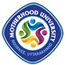

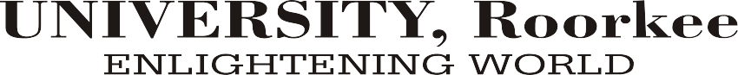

**PROFORMA FOR OBTAINING DIPLOMA/DEGREE**

To

The Registrar

Motherhood University, Roorkee

Uttarakhand

Sir,

This is to request you to please supply/ Issue my Degree/ Diploma as follows:

|  |  |  |
| --- | --- | --- |
| Course Name with Branch: | |  |
| Year of Passing: | |  |
| Roll No / Enrollment No.: | |  |
| Full Name (In Capital letter) as per qualifying examination certificate | | |
| In Hindi |  | |
| In English |  | |
| Present Mailing Address |  | |
| Absentia / Personally collect from University |  | |

Yours Faithfully,

Student’s Name & Signature

**ACCOUNT DEPARTMENT**

Bank Draft/Cash Receipt of Rs 1500/- for Diploma and Rs. 2000/- for Degree courses as fee in absentia/regular and in favour of “Motherhood University” with following particulars is/are enclosed:

Bank Draft/Cash Receipt No ………………………. Dated ………………... Amount ……….......

Account Dept.

Signature with Seal

**Examinations Department (Office Use only)**

Check form properly and enclosed self-attached document

1. Final Year Marksheet / PDC
2. Student ID Card / Any Photo ID proof.

**Asst. COE**

**COE Registrar**